Cloud Computing

# What is Cloud Computing?

Cloud computing is the delivery of computing services—such as servers, storage, databases, networking, software, and analytics—over the Internet ("the cloud"). This eliminates the need for companies or individuals to own and manage physical infrastructure.

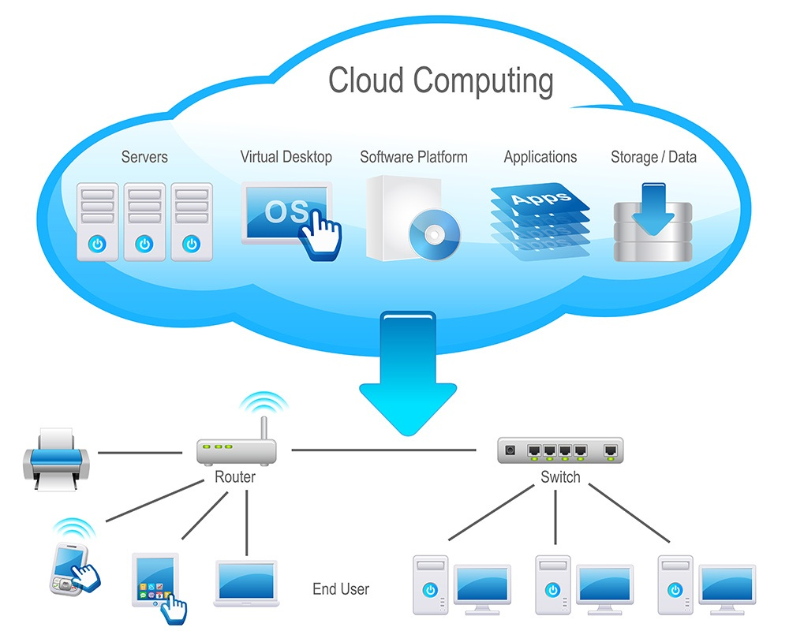

# Key Features of Cloud Computing

* On-demand access – Resources are available when needed.
* Scalability – Easily scale up or down based on requirements.
* Pay-as-you-go – Pay only for what you use.
* Accessibility – Access services from anywhere using the internet.
* Maintenance-free – The provider handles hardware/software updates.

# Cloud Service Models

## 1. IaaS – Infrastructure as a Service

Provides virtual machines, storage, and networks.  
🖥️ Example: Amazon EC2, Microsoft Azure VMs

## 2. PaaS – Platform as a Service

Offers a platform for developers to build, test, and deploy applications.  
⚙️ Example: Google App Engine, Azure App Services

## 3. SaaS – Software as a Service

Delivers software applications over the internet.  
📧 Example: Gmail, Microsoft 365, Dropbox

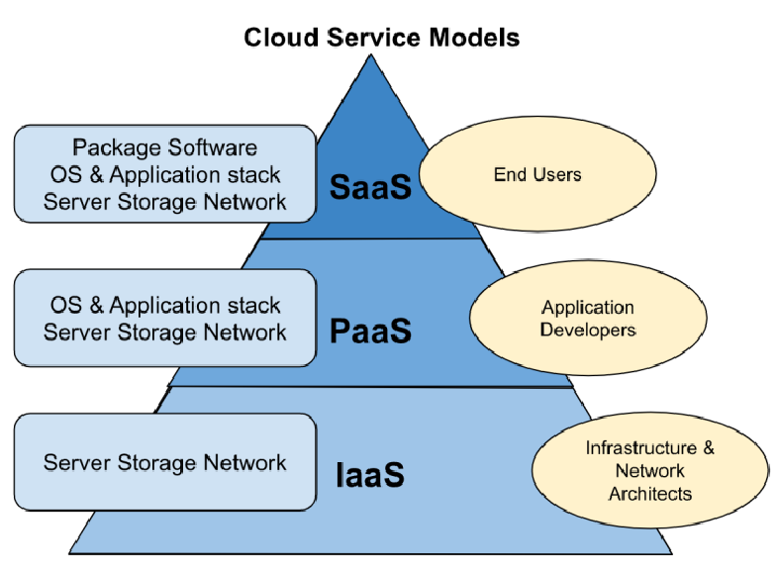

# Benefits of Cloud Computing

* Cost Savings
* Speed and Agility
* Automatic Updates
* Security and Compliance
* Global Reach

# Leading Cloud Providers

* Amazon Web Services (AWS)
* Microsoft Azure
* Google Cloud Platform (GCP)
* IBM Cloud
* Oracle Cloud

# Real-World Applications

* Online storage (Google Drive, OneDrive)
* Streaming services (Netflix, Spotify)
* E-commerce (Amazon, Flipkart)
* Remote work tools (Zoom, Slack)
* AI & Machine Learning

# Conclusion

Cloud computing has revolutionized the way we use technology. It provides flexibility, scalability, and efficiency, making it an essential component of modern IT infrastructure.